Department of Civil and Environmental Engineering
The Hong Kong University of Science and Technology

CIVL 1100
Discovering Civil and Environmental Engineering



Laboratory Report on Structural Engineering Experiments
Spring 2024

Group : A10
Date of experiment : 2024-03-05
Group members : Lam Hiu Yuet
Li Yat Fung
So Chun Hin
Sung Chun Kit

Date of submission : 2024-03-12

Test 1 – Three Pinned Arch Experiment (STR9)

  - (i) Plot a graph of ‘Experimental horizontal reaction’ (in N) as the vertical axis versus ‘Distance from left’ as the horizontal axis (in mm). Label the axes clearly, with an appropriate title.
(5 marks)

(ii) What is the relationship between the applied load and the corresponding horizontal reaction? In what position you would place a point load to maximize the horizontal reaction? Comment on the results.
(3 marks)
The closer the load is to the midpoint, the higher the magnitude of the horizontal reaction. Therefore, to maximize the horizontal reaction, the point load would be placed in the midpoint exactly. If one takes moment about the midpoint, by moving the load closer to the midpoint, the moment by the load, which counteracts the moment created by the vertical support reaction, becomes smaller, so the support itself needs more horizontal reaction to counteract the moment created by the support vertical reaction.
(You may use Excel to plot the graph, or you can plot it on a graph paper.)

  - (i) What are the support conditions of the three-pinned arch?
(1 mark)
The net vertical force equals zero, the net horizontal force equals zero, and the net moment about any point equals zero.
(ii) Develop a simplified structural model of the arch for analysis (including the arch structure, the supports, and any other necessary details of the experimental set-up you can find). Label all the dimensions on the diagram.
(3 marks)
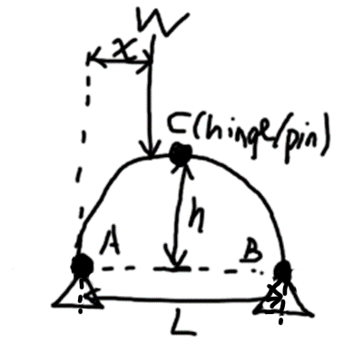
  - (i) The three-pinned arch structure is separated from supports A and B. Complete the free-body diagram of the whole arch. (Fig. 1.3(a))
(4 marks)

A
B
C
W
x
Fig. 1.3(a)
(ii) The arch is further separated at pinned connection C. Complete the free-body diagrams of the two halves. (Fig. 1.3(b))
(8 marks)

A
B
C
W
x
Fig. 1.3(b)
1.4 (i) Refer to your completed free-body diagram in Fig. 1.3 (a), write the moment equilibrium equation of the whole arch by taking moment at support B;
(1 mark)
Take counterclockwise as positive.
$$\sum_{ }^{ }{M_{B}} = -A_{y}L + W\left(L-x\right) = 0 N m$$
(ii) Refer to Fig. 1.3(b), consider the left-hand half of the arch bridge AC, write the moment equilibrium equation at pinned connection C;
(1 mark)
Take counterclockwise as positive.
$$\sum{M_{C}}=-A_{y}\left(\frac{L}{2}\right)+A_{x}h+W\left(\frac{L}{2}-x\right)=0 N m$$
(iii) From the results of (a) and (b), verify $A_{x} = \frac{W_{x}}{2h}$.
($A_{x}$ is the horizontal reaction at support A)
(3 marks)
Take counterclockwise as positive. Start from 2×1.4(ii) −1.4(i).
$$2\sum{M_{C}}-\sum{M_{B}}=0 \\ -A_y L + 2 A_x h + W(L - 2x) - (-A_y L + W(L - x)) = 0 \\ -A_{y}L+2A_{x}h+WL-2Wx+A_{y}L-WL+Wx=0 \\ 2A_{x}h -W_{x} = 0 \\ A_{x} = \frac{W_{x}}{2h}$$

  - Compare the experimental data with the theoretical values obtained in the virtual experiment. Comment on the two sets of data. Discuss the possible experimental errors.
(3 marks)
There are no clear trends on the percentage error. A weak trend is that the closer the load is to the middle, the smaller the percentage error. This is explained by when the load moves closer to the middle, the absolute error is about the same, but the theoretical value is larger, so the percentage error is smaller. Another source of error is that the measurement only measures up to 1 decimal place while the theoretical value is up to 2 decimal places. One more error source is that the actual structure is not exactly an ideal three-pinned arch, so the theoretical calculations are not completely but only approximately correct for the actual structure.
Test 2 – Redundant Truss Experiment (STR17)

2.1. Statically Determinate Structure Test

    - Indicate the purpose of measuring the initial reading in strain gauges (i.e. ‘Measured strain’ when Force = 0 N) before applying loading.
(2 marks)
So that we can subtract the initial strain from the measure strain to get the net strain. The net strain does not include the strain caused by other forces like weight, or strain gauge zero offset. It also ensures strain gauges are static.

2.1.2 Identify the state of the member force in every member, compression, tension or a zero-force member, using the measured data.
(7 marks)
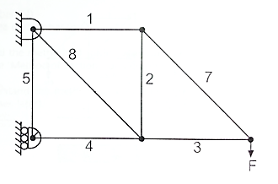
Fig. 2.1
1. Tension
2. Compression
3. Compression
4. Compression
5. Zero-force member
7. Tension
8. Tension

2.1.3 (i) Plot TWO graphs of ‘Measured Strain’ versus ‘Applied Load’ (‘Measured Strain’ is the y-axis and ‘Applied Load’ is the x-axis) for members 3 and 7 (refer to Fig. 2.1) separately. Label the axes clearly, with an appropriate title.
(8 marks, 4 marks for each graph)

For member 7, the sensor is broken and data is not available, and other members (member 8) of the same tension or compression also have their sensors broken. Therefore, theoretical values for member 7 are used:

(ii) What is the relationship between member strain and external load?
(1 mark)
The member strain and external load has a linear relationship (in fact, proportional if one correctly sets the strain value to 0 when the applied load is 0).

(iii) From the two graphs, what can you say about members 3 and 7?
(2 marks)
Member 3 is in compression as the strain values are negative. Member 7 is in tension as the strain values are positive.
(You may use Excel to plot the graphs, or you can plot it on a graph paper.)

[Note.
If the strain data from members 3 or 7 are not available, you can use the data from another member under the same tension or compression.]

    - (i) Plot a graph of ‘Measured Displacement’ versus ‘Applied Load’. On the same graph, also plot the ‘Theoretical Displacement’ versus ‘Applied Load’ as a comparison. (Please make sure the signs of displacement are correct.)
(7 marks)
Take downward displacement as positive.

(ii) What is the physical meaning of this graph, or what is the physical law behind? What does the slope of the graph tell you?
(2 marks)
The graph describes the stiffness of the system. The displacement and the applied force have a linear proportional relationship. By Hooke’s law, the stiffness is the force divided by the displacement. The slope of the curve represents the reciprocal of the stiffness, so a steeper slope indicates lower stiffness.
(You may use Excel to plot the graph, or you can plot it on a graph paper.)
    - Compare the experimental data with the theoretical results obtained in virtual experiments. Comment on the two sets of data.
(3 marks)
One clear difference is that the experimental displacement is larger than the theoretical displacement. In fact, it is almost twice as large. Another thing is that the measured strain is slightly larger than the theoretical strain. The first one may be caused by the displacement sensor being loose, leading to systematic error. The second one may be caused by the members having been used previously, so the material may be weakened, leading to lower Young’s modulus and thus higher strain.
    - Explain the reading of member 5.
- marks)
The theoretical strain of member 5 is always 0 and the measured strain of member 5 is very close to 0. Consider the member 5 joint connected to the roller support. In short, there are three things connected to the joint that can apply force, and two of them are collinear. That means the non-collinear one, which is member 5 here, has no axial force, so its strain should be 0.

In long, theoretically, the joint is static, so its horizontal and vertical net forces are both 0. As the support is a horizontal roller support, it can only provide horizontal force but not vertical force to the joint. The member on the right of the joint is also horizontal and can only provide horizontal force as well. That means the only way to apply vertical force is via member 5, and that means the vertical force applied by member 5 is 0 in order for the vertical net force to be 0, so the strain of member 5 should be 0.
    - (i) Complete the free-body diagram for the statically determinate cantilever truss shown below.
(3 marks)

(ii) Calculate the reactions if the external force F = 50 N. Show your step-by-step calculations.
(5 marks)
(i)

50 N
(ii) Take upward, right, and counterclockwise as positive.
$$\sum{M_{A}}=0 \\ -50\left(0.48\right)+0.24B_{x}=0 \\ B_{x}=100 \text{N}$$

$$\sum{F_{y}}=0 \\ A_{y}-50=0 \\ A_{y}=50\text{ N}$$

$$\sum{F_{x}}=0 \\ A_{x}+B_{x}=0 \\ A_{x}+100=0 \\ A_{x}=-100\text{ N}$$
    - (i) Complete the following force diagrams.
(6 marks)
(ii) Determine ALL the member forces (6 members) when F = 50 N. Please show your calculation steps clearly.
(9 marks)
(i) Assume all member forces are in tension for calculation purposes.
50 N
7
3
7
1
2
2
4
3
8
(ii) Take up, right, tension, and counterclockwise as positive.
$$\sum_{ }^{ }{E_{y}} = 0 \\ F_{DE}\cos{45°} - 50 = 0 \\ F_{DE}= 50\sqrt{2} N$$

$$\sum_{ }^{ }{E_{x}} = 0 \\ -F_{DE}\cos{45°} - F_{CE}= 0 \\ F_{CE}=- 50 N$$

$$\sum_{ }^{ }{D_{y}} = 0 \\ {-F}_{CD} -F_{DE}\cos{45°}= 0 \\ F_{CD}=-50 N$$

$$\sum_{ }^{ }{D_{x}} = 0 \\ -F_{AD}+F_{DE}\sin{45°}=0 \\ F_{AD} =50 N$$

$$\sum_{ }^{ }{C_{y}} = 0 \\ F_{CD} + F_{AC}\cos{45°}= 0 \\ F_{AC} = 50\sqrt{2} N$$

$$\sum_{ }^{ }{C_{x}} = 0 \\ -F_{BC}+F_{CE}-F_{AC}\sin{45°}= 0 \\ F_{BC} = -100 N$$

  - Statically Indeterminate Structure Test

2.2.1 (i) Compare the slope of the displacement-load graphs in the first experiment and this experiment (not necessarily to plot the graphs).
(1 mark)
The slope of the displacement-load graph in the first experiment is steeper than that of the second experiment.
(ii) Compare the overall stiffness of the two trusses.
(1 mark)
The overall stiffness of the statically indeterminate truss is higher than that of the statically determinate truss because the displacement of the former truss is less than the latter when given the same applied force.
    - Identify the major differences after member 6 is added in the indeterminate truss.
(2 marks)
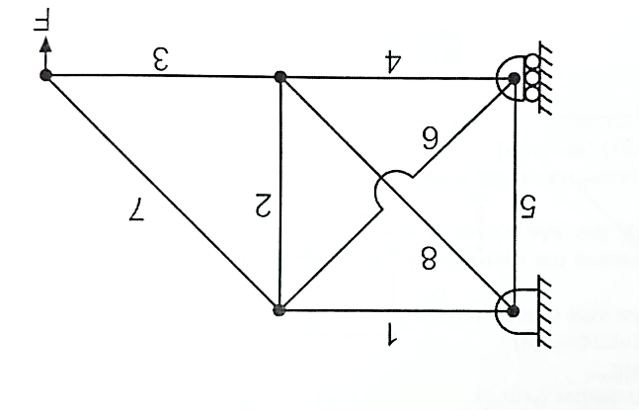
Member 5 changes from a zero-force member to being in tension. The maximum magnitude of the theoretical strain and measured strain out of all members both decrease given the same applied load. This shows the applied force is more evenly distributed throughout the members.
    - According to the comparisons presented in 2.2.1 to 2.2.2, what do you think about the safety and economy of the two different structures? What are the possible pros and cons of adopting an indeterminate truss design? (Open-ended question)
(4 marks)
From 2.2.1, the stiffness of the system increases after adding member 6. This means the structure resists forces better, making it safer. From 2.2.2, after adding member 6, the maximum magnitude of the theoretical strain and measured strain out of all members both decrease given the same applied load. This shows the applied force is more evenly distributed throughout the members, meaning each member is less likely to break by itself individually and leading to the collapse of the whole system by domino effect, also making it safer. The only potential downside is that the statically indeterminate structure requires more advanced techniques to calculate the forces, leaving the room for more human mistakes, but this can be mitigated by computers and is not an inherent flaw in the design. So, the statically indeterminate structure is safer than the statically determinate one. However, in terms of economy, the statically indeterminate truss has more members than the determinate one, so more material is required and the building cost increases, so the indeterminate one is less economical.

(Please attach ONE complete set of lab record sheets at the end of this report.)

~ End of the report ~

